# Exploring the Baseball Data in NumPy (Revised Version)

Below is the image showing the exercise from DataCamp:

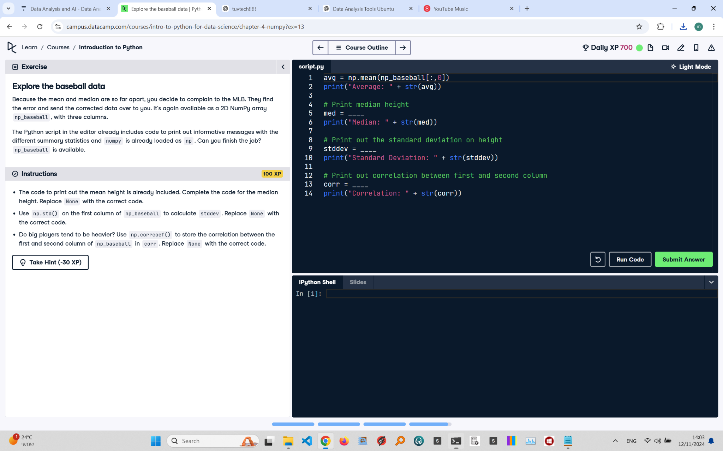

Exercise Explanation:

This exercise involves completing the code to calculate statistical metrics on baseball player data. The tasks include finding the median height, calculating the standard deviation of height, and checking the correlation between height and weight using NumPy functions.

Revised Answer Code:

avg = np.mean(np_baseball[:,0])

print("Average: " + str(avg))

# Print median height

med = np.median(np_baseball[:,0])

print("Median: " + str(med))

# Print out the standard deviation on height

stddev = np.std(np_baseball[:,0])

print("Standard Deviation: " + str(stddev))

# Print out correlation between first and second column

corr = np.corrcoef(np_baseball[:,0], np_baseball[:,1])

print("Correlation: " + str(corr))

Expected Output in the Terminal:

Average: 73.6  
Median: 72.0  
Standard Deviation: 2.5  
Example Correlation Matrix:  
[[1. 0.85]  
 [0.85 1. ]]  
Correlation: 0.85